**Experiment 3**

**To Implement Sampling and Quantization**

**Roll no. 4117**

**Resize the image:**

import cv2

src = cv2.imread('car.jpg')

img=cv2.resize(src, (300, 300))

print (src.shape)

print(img.shape)

cv2.imshow('Original',src)

cv2.imshow('Resize',img)

cv2.waitKey(0)

cv2.destroyAllWindows()

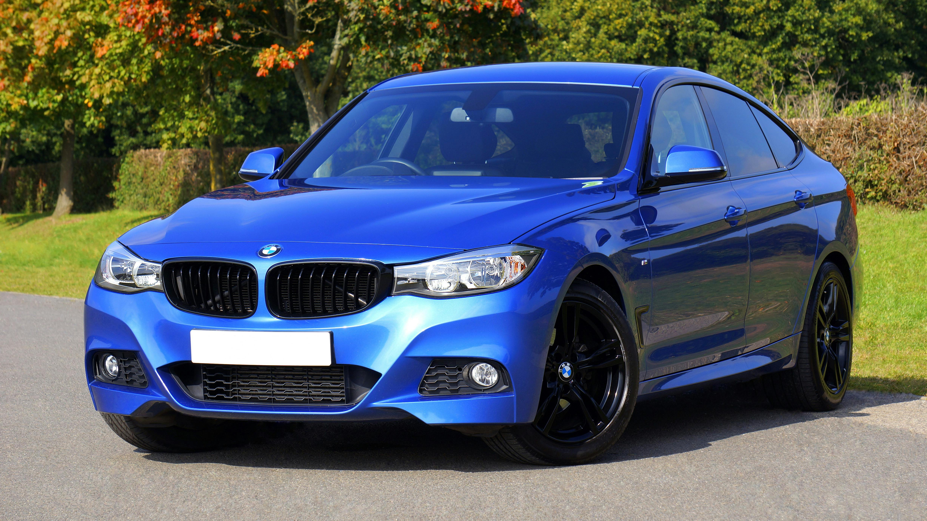

Resize:

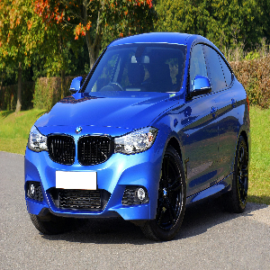

**Resize in percent:**

import cv2

src=cv2.imread('car.jpg')

percent=50

print(src.shape)

width=src.shape[1]

w = int(width * percent / 100)

height=src.shape[0]

h = int(height * percent / 100)

resize=cv2.resize(src,(h,w))

print(resize.shape)

cv2.imshow("Resize", resize)

cv2.waitKey(0)

cv2.destroyAllWindows()

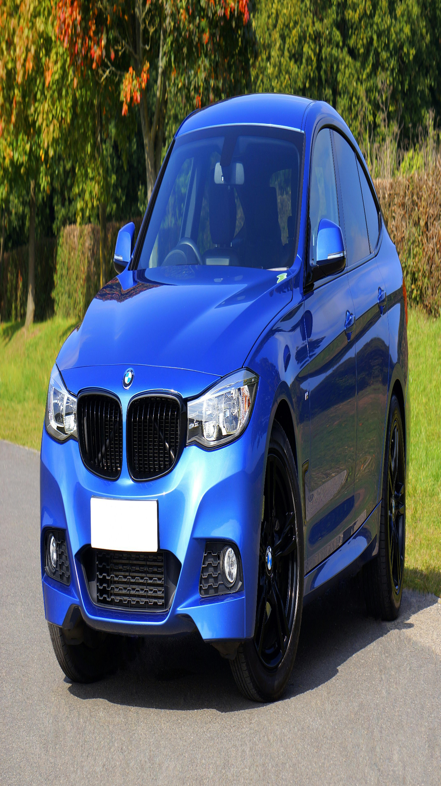

**Pyramid:**

import cv2

import matplotlib.pyplot as plt

img=cv2.imread("car.jpg")

layer=img.copy()

for i in range(4):

    plt.subplot(2, 2, i+1)

    layer=cv2.pyrDown(layer)

    cv2.imshow("str(i)", layer)

    cv2.waitKey(0)

cv2.destroyAllWindows()

**Quantization:**

import cv2

import numpy as np

img=cv2.imread("car.jpg", cv2.IMREAD_GRAYSCALE)

cv2.imshow("original image", img)

cv2.waitKey(0)

cv2.destroyAllWindows()

def quantize(img, levels):

    max_val=256

    step=max_val//levels

    x= (img // step)* step

    return x

q4=quantize(img, 4)

q16=quantize(img, 16)

q64=quantize(img, 64)

cv2.imshow("original image", img)

cv2.imshow("4 level", q4)

cv2.imshow("16 level", q16)

cv2.imshow("64 level", q64)

cv2.waitKey(0)

cv2.destroyAllWindows()